Review 2 Slide by Slide Technical Presenter Guide
Plain-language explanations with the data, models, metrics, evidence, and limits behind every slide
Prepared for the updated 15-slide capstone presentation. Use this as a learning document and speaking aid: the “say it” portions are presentation-ready, while the notes unpack the technical meaning and the claims that should stay carefully qualified.
Project: Predictive and Uncertainty-Aware Scheduling of Apache Iceberg Storage Maintenance Under Concurrent Analytical Workloads
Team: Shashank Keshava Murthy, Shashank D, Prachi Jalan, Samarth Rao

How to use this guide
- Read the short project story and vocabulary first. Then read each slide section beside the slide screenshot.
- This guide expands the earlier capstone_presentation_explainer_2026-11-03.docx using the updated 15-slide Review 2 deck. The older guide remains a useful earlier explanation; this file follows the current slide order and wording.
- “Say it” is a natural way to explain the slide aloud. “What it means” and “technical detail” are your deeper understanding, especially for questions.
- The guide separates what is implemented, what was measured, and what remains a research question. Keep those categories separate in the presentation.
- All screenshots below are rendered from the updated Review 2.pptx in this folder. If the deck changes again, rerender and recheck the matching slide sections.

The project in one clear story
Apache Iceberg tables are stored as data files. As data is added and changed, a table can accumulate many small files. Compaction rewrites files into a more efficient layout. That rewrite consumes compute and storage I/O while analytical queries may be running, so it can slow queries. A fixed overnight schedule ignores the workload, while a rule that reacts only to current CPU load cannot see an upcoming busy period.
Our research question is whether a system can choose a better time for compaction by combining (1) estimated query service time under observed maintenance states, (2) a forecast of offered query arrivals, and (3) the real FIFO queue and measured cost/benefit of the rewrite. The intended outcome is lower arrival-to-result time for the whole query cohort without hiding queueing, dropped requests, or unsupported predictions.
The most important qualification: this is the proposed research system and evaluation target. The slides report that there are no accepted model fits or policy wins in the reviewed evidence yet. We have engineering components and exploratory measurements, but the core timing benefit remains to be demonstrated.

Vocabulary before the slide walkthrough
Term | In everyday language | How it is used here
Apache Iceberg | A table format that tracks data files and table snapshots. | The system under study; compaction rewrites files and creates a new table state.
Compaction / rewrite | Combining or rewriting data files to improve the table layout. | A maintenance action that costs time/resources now and may improve later queries.
TPC-H SF10 | A standard benchmark business database at scale factor 10. | The controlled dataset/schema. The slide reports about 60M lineitem rows and ~10 GB raw data.
Snowset arrivals | Recorded timestamps showing when source queries arrived in a real workload trace. | Used to drive a replay schedule; the original Snowflake SQL is not available for this replay.
Offered arrivals | Requests that the workload generator is supposed to present to the system. | Must include arrivals even if the service is busy; backlog and late completion cannot be hidden.
Service time | Time spent executing a query after it is dispatched. | The A/B model target; it excludes time waiting in the dispatch queue.
Queue wait | Time a query waits before execution begins. | A scheduler-visible delay. It must be included when evaluating full user-facing response.
Response time | Time from offered arrival until result completion. | For this project, arrival-to-result = queue wait + service time, with replay/dispatch overhead accounted for consistently.
FIFO | First in, first out. | The external queue dispatches earlier queued requests before later ones, subject to the registered policy.
Independent episode/block | A separately collected workload/maintenance episode. | The unit that supports generalization; many queries from one rewrite are not many independent experiments.
Coverage | How often the model is willing and able to make a supported prediction. | Must be reported beside error; low error on a tiny supported subset is not enough.
Out-of-range refusal | The model declines to guess when inputs differ too much from training evidence. | A safety behavior, not a prediction result or proof of calibrated uncertainty.

The three model roles and their actual inputs
The labels A, B, and C name separate prediction jobs. They are not three interchangeable “AI models.” A and B estimate a query’s service time under two observed client-maintenance conditions. C estimates future query-arrival counts from past arrival history. A queue-aware controller would use these estimates alongside live queue state, a separate rewrite-duration estimate, and evidence about how compaction changes layout. A/B/C alone do not make the scheduler.
Component | Question it answers | Target/output | What its output does not mean
A | How long might this kind of query take when our maintenance client has a request pending? | Estimated query service time in milliseconds, conditional on the observed client pending state. | Pending is not proof the Spark engine was executing a rewrite at the same instant; this is not a proven causal slowdown.
B | How long might the query take when our maintenance client has no request pending? | Estimated service time in milliseconds for the observed no-pending condition, given the actual table layout and context. | B is not automatically the counterfactual for A. Layout, query, host load and time must be comparable.
C | How many queries may arrive over a future time window? | Forecast count of offered arrivals per registered horizon/window. | A count is not CPU demand, bytes scanned, query mix, or arrival-to-result time; it does not by itself prove a good compaction window.

The registered 22-field input contract
The current SF10 model registration lists these exact 22 inputs. The first 14 form the explicit query/context/host feature contract shown in the evidence documentation; the last 8 come from the actual pre-execution query plan. Features must exist at decision time. The model cannot use the same query’s future runtime or result as an input.
# | Field name | What the value represents | When it is available / caution
1 | query_id | ID of one of the six controlled query templates. | Known before dispatch. With only six templates, it can act like a shortcut; plan features may not generalize.
2 | file_count | Number of data files in the registered intervention-table snapshot. | Read from table/layout metadata before the query; not necessarily the file count of every table the query scans.
3 | record_count | Row count recorded for that intervention table/layout. | Snapshot/layout metadata; quality depends on metadata freshness and exact snapshot binding.
4 | total_bytes | Total bytes of files in the intervention-table layout. | Pre-query metadata; not bytes actually scanned by this query.
5 | maintenance_client_pending_at_feature_time | Whether this client had a maintenance request pending at the feature snapshot. | Captured by the controller before query submission. Does not certify engine overlap or causal interference.
6 | queue_depth_at_feature_time | Number of requests in the controller’s FIFO queue at feature time. | Controller state at prediction time; do not substitute post-dispatch queue values.
7 | cpu_busy_fraction_60s | Host CPU busy fraction over the prior 60 seconds. | Past-only host telemetry; fraction (0–1). Not a future CPU forecast.
8 | memory_used_fraction_60s | Host memory-used fraction over prior 60 seconds. | Past-only; describes the monitored host, not necessarily all cluster resources.
9 | read_bytes_per_second_60s | Host read throughput over prior 60 seconds. | Past-only telemetry; preserve source and sampling gaps.
10 | write_bytes_per_second_60s | Host write throughput over prior 60 seconds. | Past-only telemetry; a rewrite may affect this after action starts, but future writes are not known at decision time.
11 | cpu_busy_fraction_300s | Host CPU busy fraction over prior 300 seconds. | A longer context window; highly overlapping with the 60s measurement.
12 | memory_used_fraction_300s | Host memory-used fraction over prior 300 seconds. | Longer context, same host/scope caveat.
13 | read_bytes_per_second_300s | Host read throughput over prior 300 seconds. | Longer context, not independent from the 60s feature.
14 | write_bytes_per_second_300s | Host write throughput over prior 300 seconds. | Longer context, not independent from the 60s feature.
15 | plan_operator_count | Total operators in the pre-execution query plan. | Plan-derived before execution. Must be extracted from the actual plan, not guessed from SQL text.
16 | plan_scan_count | Number of scan operators. | Pre-execution plan structure.
17 | plan_join_count | Number of join operators. | Pre-execution plan structure.
18 | plan_aggregate_count | Number of aggregate operators. | Pre-execution plan structure.
19 | plan_exchange_count | Number of data exchange/shuffle operators. | Pre-execution plan structure; does not directly give shuffle bytes.
20 | plan_sort_count | Number of sort operators. | Pre-execution plan structure; does not say how many rows will be sorted.
21 | plan_filter_count | Number of filter operators. | Pre-execution plan structure; does not reveal selectivity unless separately measured before execution.
22 | plan_window_count | Number of window operators. | Pre-execution plan structure.

What is intentionally absent: the current query’s actual runtime, actual bytes scanned, output row count, final result, or later host telemetry. Those are post-decision outcomes and would leak the answer into the inputs. A valid model row binds features to the exact query, source episode, layout/snapshot and time at which the decision could have been made.

What is data versus what is generated by our testbed?
Source | Real part | Controlled / imposed part | Why the distinction matters
Snowset | Recorded arrival timestamps and source-workload chronology. | The replay maps each arrival to one of six TPC-H-derived SQL templates; Snowset’s original SQL text/workload mix is not recovered. | Real arrivals provide timing patterns, not an exact reproduction of the source SQL or its resource demand.
TPC-H SF10 | Standard table schema and generated benchmark rows. | The testbed’s physical Parquet/Iceberg layout (including registered file counts), selected six SQL templates, and maintenance schedule. | A reproducible benchmark workload is not the same as production data or the original Snowflake query set.
Host telemetry | Values sampled from the actual worker/engine environment during collection. | The registered windows and collection cadence. | Sampling gaps or host drift can invalidate comparisons; a saved configuration does not prove complete measurements.
Maintenance labels | Observed request-pending state and actual measured service outcomes. | The controlled time at which a run requests maintenance. | Pending-state comparisons can be confounded by layout, timing, and host conditions unless matched and independently repeated.

Metrics you will hear in the deck
Metric | Meaning | How to explain a value | What it cannot establish alone
MAE (mean absolute error) | Average absolute gap between a prediction and the observed target. | An MAE of 20 ms means predictions were off by 20 ms on average in absolute value for the evaluated rows/episodes. | It does not say whether the model beats a baseline significantly, is calibrated, covers all cases, or improves scheduling.
Equal-episode MAE | Calculate MAE within each held-out episode, then average episode errors equally. | A long episode with many query rows cannot dominate solely because it has more rows. | Still not independent evidence if the “episodes” overlap or share the same source/rewrite family.
Forecast count MAE | Average absolute error in the number of arrivals over a forecast horizon. | MAE 7 requests means the horizon count differs from actual by seven requests on average. | Does not describe query cost or queue response; overlapping horizons are dependent.
Response time | Arrival-to-result time for each offered query. | Includes queueing plus execution (and consistently measured replay/dispatch delay). | Must report whole-cohort distributions and failed/uncompleted requests; completed-only metrics can look deceptively good.
Prediction coverage | Fraction of requested predictions that are supported and returned. | If only 30% are supported, a low MAE on that 30% says little about the other 70%. | Not uncertainty calibration by itself.
Uncertainty calibration | Whether stated prediction intervals match their advertised frequency on new data. | For example, a 90% interval should contain roughly 90% of comparable future outcomes under valid conditions. | No calibration claim is supported by the SF1 bar chart.

Slide 1 Title and project identity
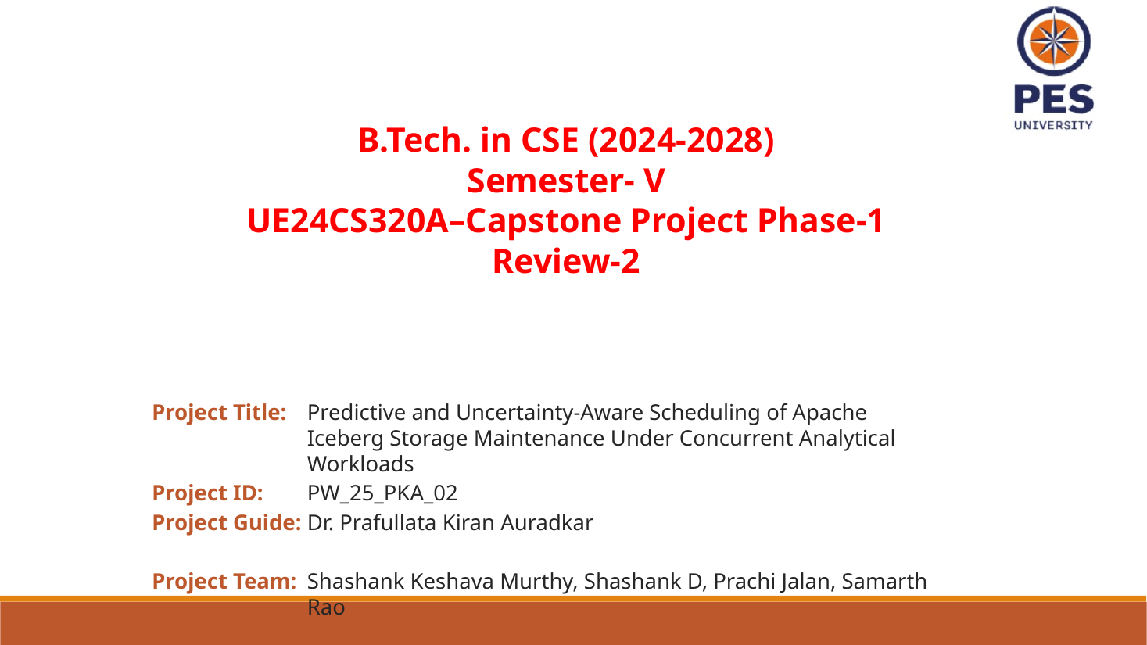
Updated deck screenshot • slide 1 of 15
Purpose: Set the research problem, not a proven result.
Say it aloud: “We are studying whether Apache Iceberg compaction can be scheduled using predicted workload conditions, so maintenance happens when its cost to active analytics is lower. This review reports our current system and evidence; it does not yet claim a winning scheduler.”
What the slide means: The title contains three promises: prediction (estimate future/conditional behavior), uncertainty-aware (know when evidence is weak), and scheduling (choose action time). The “under concurrent analytical workloads” phrase says queries continue while maintenance may be pending or running. The project is not changing the Iceberg file format or rewriting Spark’s query optimizer.
Technical / evidence note: Do not introduce the work as a finished predictive scheduler. The later status slide explicitly says no accepted fit or policy win exists. The honest contribution today is the research question, controlled testbed, and evidence plan.

Slide 2 Outline
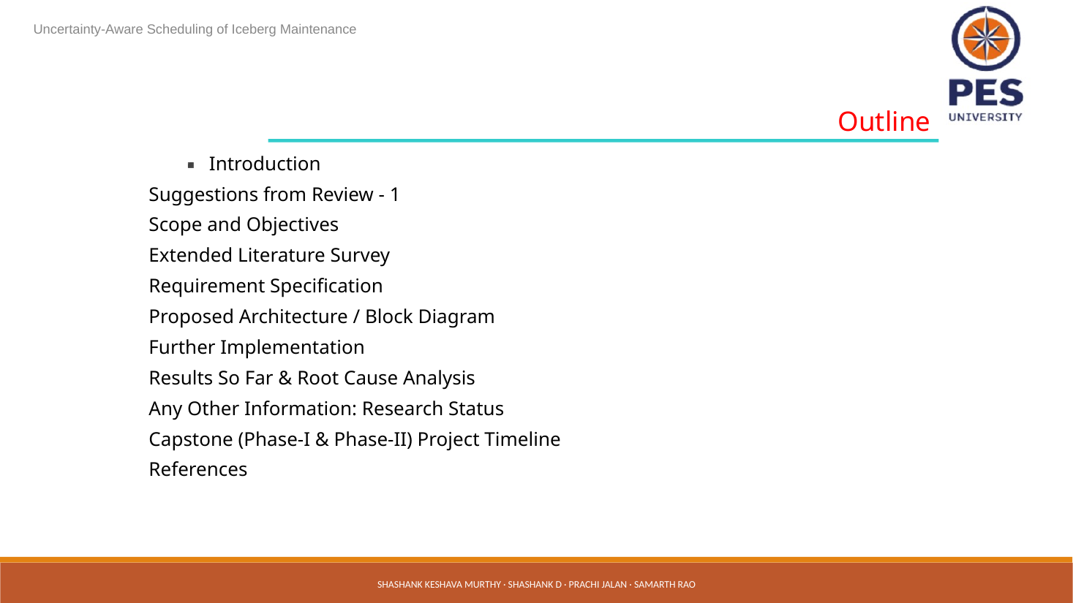
Updated deck screenshot • slide 2 of 15
Purpose: Show the audience the route through the argument.
Say it aloud: “I will start from the maintenance-timing problem, explain our controlled workload and models, show what current measurements do and do not say, and end with the next evidence gate.”
What the slide means: The order is problem → prior work → requirements and architecture → implementation/results → research status. This is useful because the result slides are easier to interpret after the audience understands that A/B predict service time, C predicts arrivals, and a full policy must account for queue waits and rewrite cost.
Technical / evidence note: The outline lists many standard review headings. Keep each one tied to the project question; do not let the talk become a tour of components without an evaluation claim.

Slide 3 Introduction
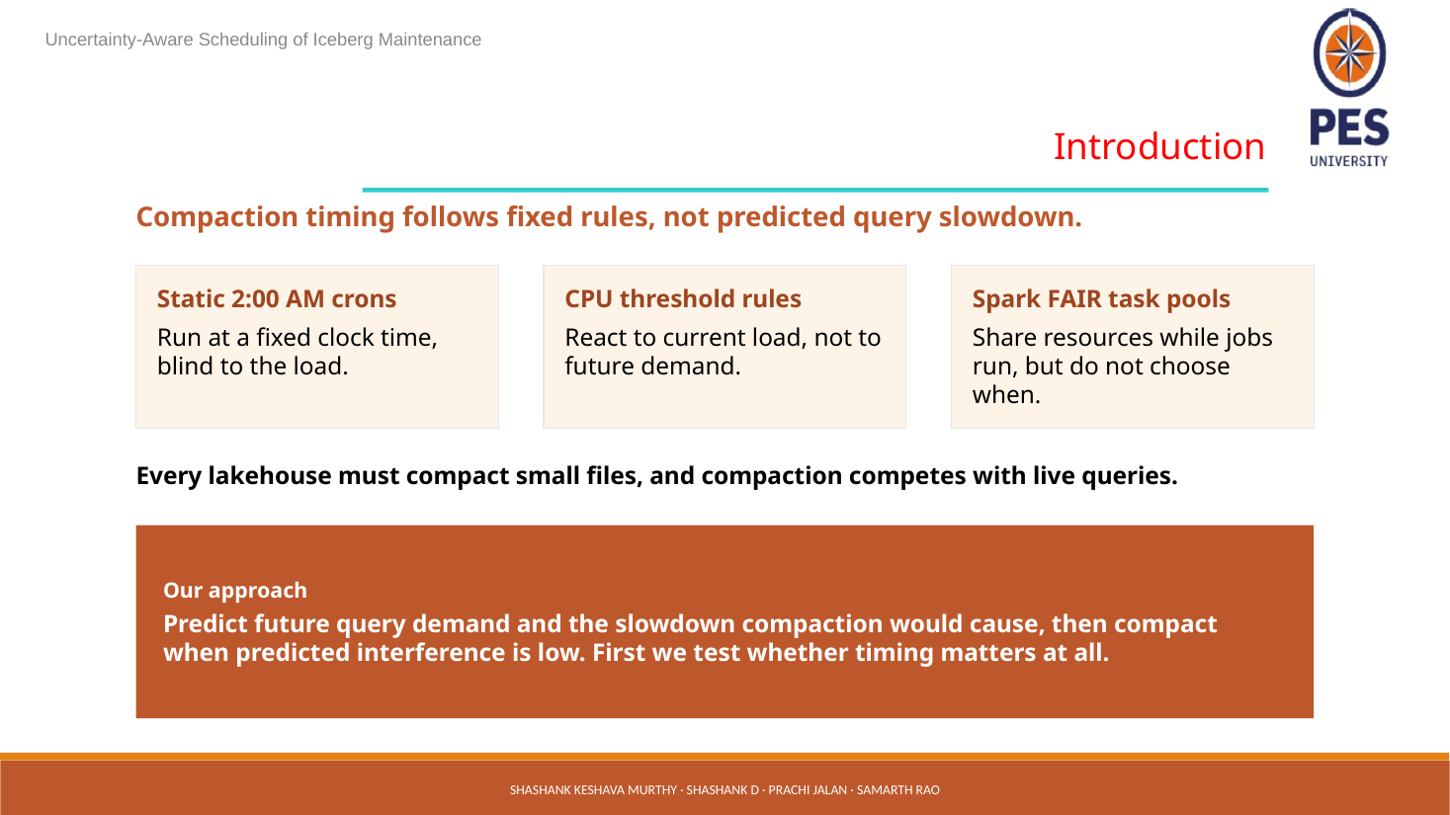
Updated deck screenshot • slide 3 of 15
Purpose: Explain why a fixed compaction schedule can make the wrong choice.
Say it aloud: “A 2 a.m. cron chooses by clock, not by actual or expected workload. A CPU threshold sees current conditions but may miss a busy period arriving soon. Spark’s FAIR scheduler shares resources among running jobs, but it does not decide when Iceberg maintenance should start. We want to test whether predicting future arrivals and interference can improve that timing. First we have to prove that timing creates a repeatable trade-off.”
What the slide means: Compaction is not automatically harmful or beneficial at every moment. It consumes resources during rewrite and may improve later scans by changing the file layout. The useful research quantity is the net effect over a workload horizon, including the work delayed while maintenance runs and the benefit after the layout changes. “Every lakehouse must compact” is rhetorically broad: say that many lakehouse tables need file maintenance as their file layout evolves, not that every table always needs compaction.
Technical / evidence note: The phrase “predict query slowdown” is a goal, not current evidence. The next experiment must compare the same maintenance action at different registered times with matched layouts, workload blocks, and complete offered-query accounting.

Slide 4 Review 1 suggestions and TPC-H
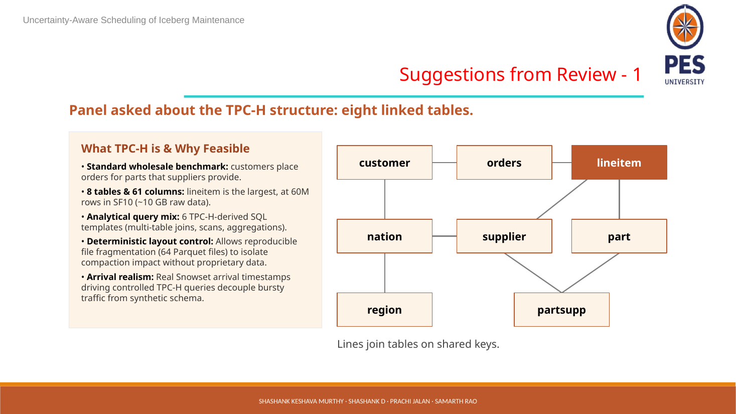
Updated deck screenshot • slide 4 of 15
Purpose: Answer what the benchmark is, how its schema is structured, and why it is controlled.
Say it aloud: “TPC-H is a standard wholesale-business benchmark: customers place orders, and line items refer to parts and suppliers. Its eight linked tables give us realistic analytical joins without using private business data. We use SF10, six TPC-H-derived queries, and controlled Parquet layouts. Snowset contributes observed arrival times, while our testbed supplies the SQL templates. So the arrival timing is trace-based, but the original Snowflake SQL mix is not replayed.”
What the slide means: The eight tables are CUSTOMER, ORDERS, LINEITEM, NATION, SUPPLIER, PART, REGION and PARTSUPP. They connect through keys: for example, orders link to customers; lineitems link to orders, parts and suppliers; geography tables connect supplier/customer nation to region. Joins let the benchmark exercise scans, joins, grouping and sorting. SF10 is a scale setting; the slide reports roughly 60 million LINEITEM rows and approximately 10 GB raw data. Treat these as benchmark-scale figures, not a measurement of compressed Iceberg storage on the worker. “64 Parquet files” is a controlled layout condition in this testbed, not a property inherent to TPC-H.
Technical / evidence note: Snowset provides timestamps for when source queries arrived. Our replay maps them onto six selected TPC-H-derived templates. This is a hybrid workload: recorded timing + imposed benchmark SQL. It is stronger than inventing a sine-wave workload, but it does not recreate Snowflake’s original SQL or resource profile. If asked “is this a real SQL trace?” answer: “No. We use real Snowset arrival timestamps, but Snowset’s original SQL is unavailable to our replay, so we execute a controlled six-query TPC-H-derived mix. We are explicit about that limitation.”

Slide 5 Scope and objectives
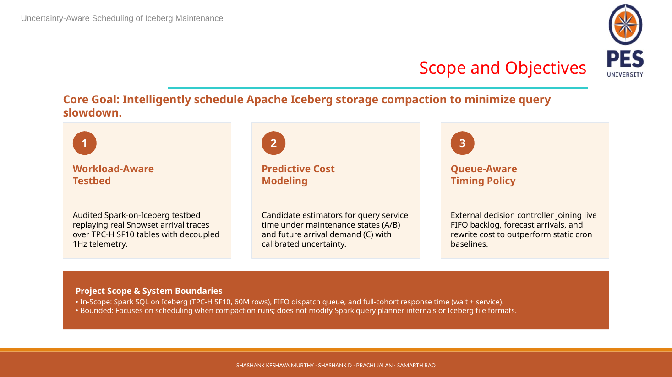
Updated deck screenshot • slide 5 of 15
Purpose: Present the system boundary and the three prediction/control layers.
Say it aloud: “Our scope is an external controller around Spark SQL and Iceberg. A and B estimate service time under two observed maintenance-client conditions; C forecasts future arrival counts. The controller combines those predictions with the live FIFO queue and rewrite cost, then we evaluate arrival-to-result time for the full offered cohort. We do not modify Spark’s query planner or Iceberg’s file format.”
What the slide means: The three numbered boxes are roles, not three validated modules that already win. A/B target service time; they are not queue-wait predictors. C forecasts request counts; arrivals are not equivalent to CPU demand. The policy also needs a maintenance duration/resource estimate and an evidenced layout benefit. “Calibrated uncertainty” is an objective in the slide, but do not imply it is already achieved: later evidence says accepted fits/calibration/policy wins are absent.
Technical / evidence note: Q1: Can we measure timing differences without layout/cache/host confounding? Q2: Is pending-state support balanced and comparable? Q3: Can a forecast improve a real queue-level objective against fair baselines? These questions are prerequisites, not optional model tuning.

Slide 6 Extended literature survey
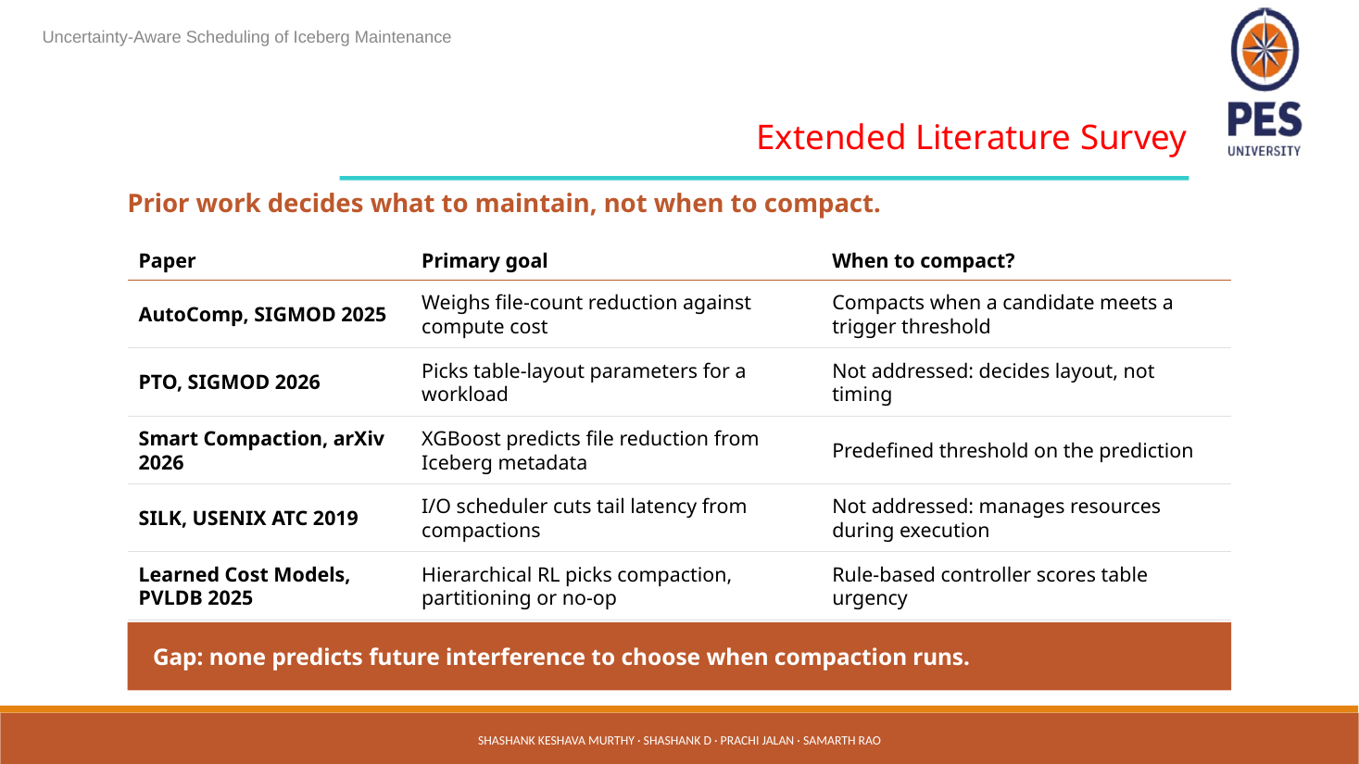
Updated deck screenshot • slide 6 of 15
Purpose: Position the gap as a testable hypothesis and show awareness of adjacent work.
Say it aloud: “There is work on choosing which tables or files to optimize and work on predicting cost or compaction utility. Our question is narrower: can future workload conditions help choose when to run maintenance? We treat that as a research gap to verify carefully, not as a claim that no prior paper has ever considered timing.”
What the slide means: The slide’s statement “Prior work decides what to maintain, not when to compact” is a broad literature claim. One slide of references is not a systematic review and cannot prove “none predicts future interference.” Explain the proposed distinction: what/which-table decisions versus when-to-start decisions under future demand and queue state. Prior work may overlap in parts of this framing, so the final paper must compare objective, signals, action, queue model, and evaluation for every closest system.
Technical / evidence note: Do not say “we are the first” based only on this slide. For a top database venue, document the search strategy, close-work comparison table, exact differences, and why those differences matter. Mention that the current novelty claim is under validation.

Slide 7 Requirement specification
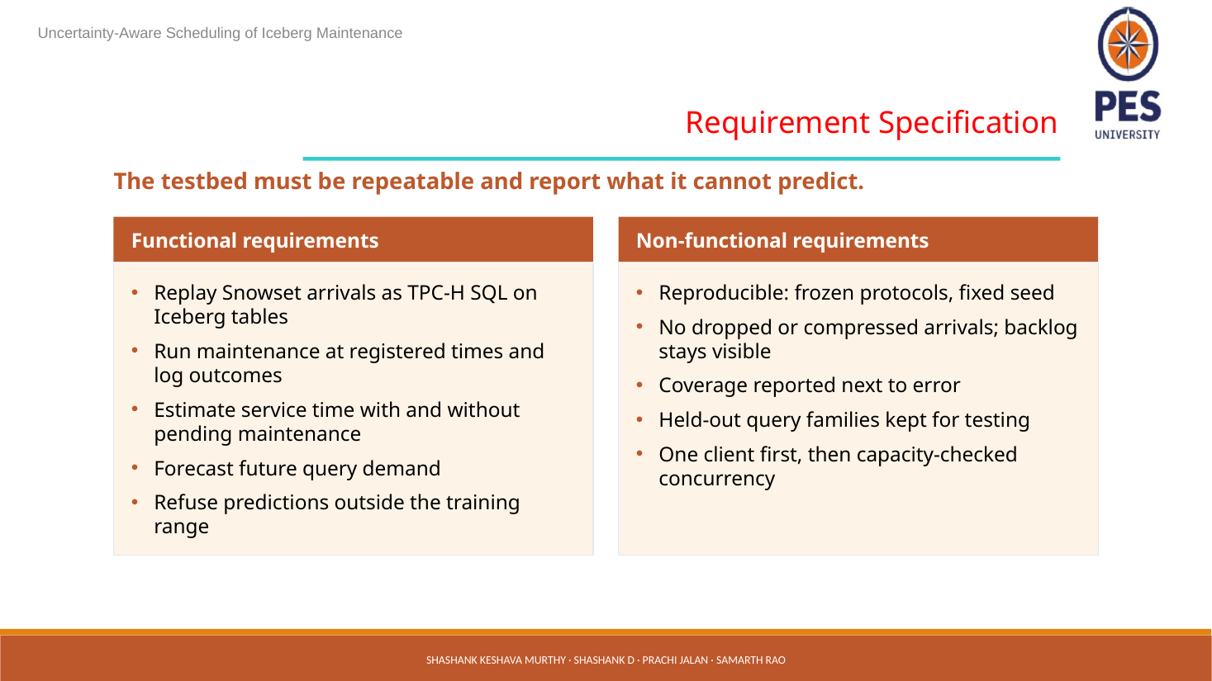
Updated deck screenshot • slide 7 of 15
Purpose: Explain what a valid experiment and safe predictor must do.
Say it aloud: “We preserve every offered arrival and make backlog visible. We register when maintenance runs, estimate query service under the two observed conditions, forecast arrivals, and refuse to guess outside the evidence range. We report coverage with error and hold out whole query families, so test rows are not just near-duplicates of training rows.”
What the slide means: “Fixed seed” helps make controlled generation repeatable, but it does not remove physical host drift. “No dropped or compressed arrivals” means arrivals must not be silently discarded or merged when the system is busy; instead, the queue grows and that delay is counted. One client first is a capacity/safety boundary; concurrent clients are added only after resources and instrumentation are checked.
Technical / evidence note: A holdout split by rows is weak when many queries came from one rewrite or source time window. The unit of separation should be independent episodes/source-window families; repeated observations from the same family must not leak between training and test.

Slide 8 Proposed architecture and block diagram
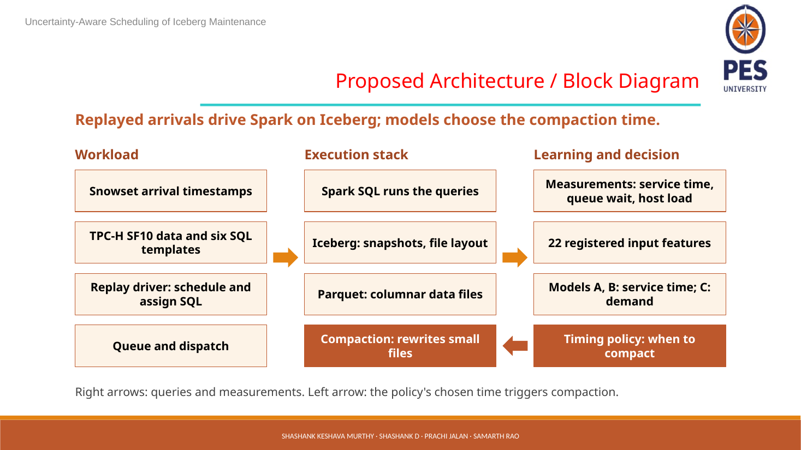
Updated deck screenshot • slide 8 of 15
Purpose: Walk the arrows, then explain where the models and queue fit.
Say it aloud: “Snowset timestamps schedule offered requests. Our replay driver maps each to one of six TPC-H queries. Requests enter the external FIFO queue; Spark SQL executes against Iceberg tables stored as Parquet files. We collect pre-decision features, observed service and queue times, and host telemetry. A/B estimate service time, C forecasts offered arrivals, and the external controller chooses whether to start, wait, or do nothing. The resulting rewrite changes Iceberg’s file layout, and we measure the whole cohort.”
What the slide means: Snowset arrival timestamps are the replay clock, not a Snowset SQL statement. The queue is important because the scheduler acts before dispatch: a query can wait even if its execution time is small. The figure’s left arrow means a timing decision causes maintenance; rightward arrows carry workload, execution and measurements. Compaction changes the table snapshot/file layout. The next prediction should use the new observed layout, not assume a benefit that has not been measured.
Technical / evidence note: Need separately estimate rewrite duration and resource use and quantify layout transition. A−B is not a valid rewrite-cost estimate; query service times under two observed states are not the cost of the maintenance action or a clean counterfactual.

Slide 9 Further implementation and scale-up
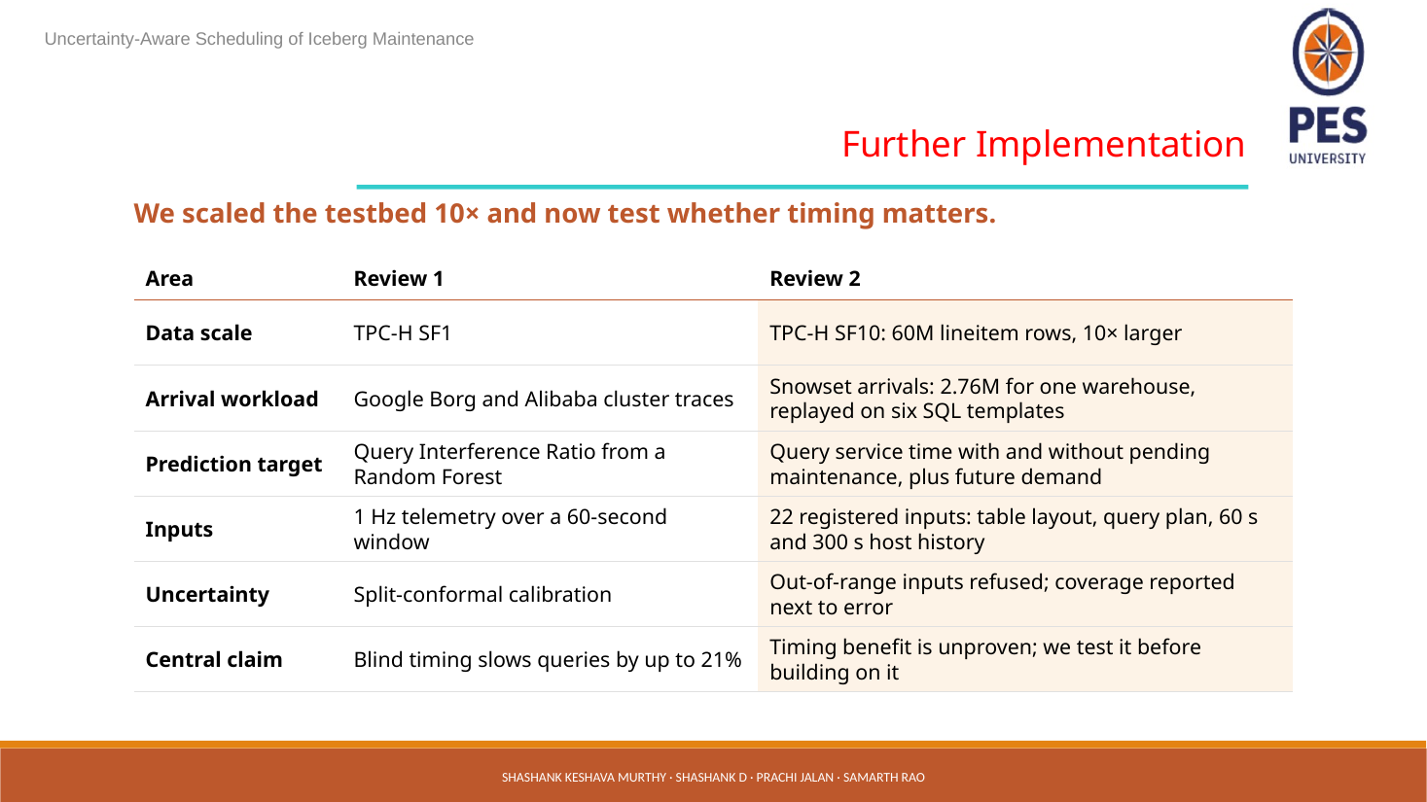
Updated deck screenshot • slide 9 of 15
Purpose: Describe what changed from the earlier phase without overstating progress.
Say it aloud: “We moved the testbed from SF1 to SF10, increasing benchmark scale by roughly ten times, and replaced the earlier synthetic demand-profile idea with Snowset arrival timestamps. The important next test is not just running bigger tables; it is checking whether the same maintenance action has a repeatable timing effect under matched conditions.”
What the slide means: This slide is intentionally a transition. SF10 refers to scale factor 10 in TPC-H; the deck reports about 60M LINEITEM rows. Scale-up can reveal operational or performance behavior that a small pilot misses, but scale alone does not validate the models or scheduler. Six SQL templates and a single source workload family still limit generalization. “Now test whether timing matters” is the central scientific gate.
Technical / evidence note: If asked what the old 21% claim means: the project has explicitly withdrawn it as an established result. No percentage benefit is currently established; the current slide 12 says there are zero policy wins in reviewed records.

Slide 10 Results so far: SF1 model comparison
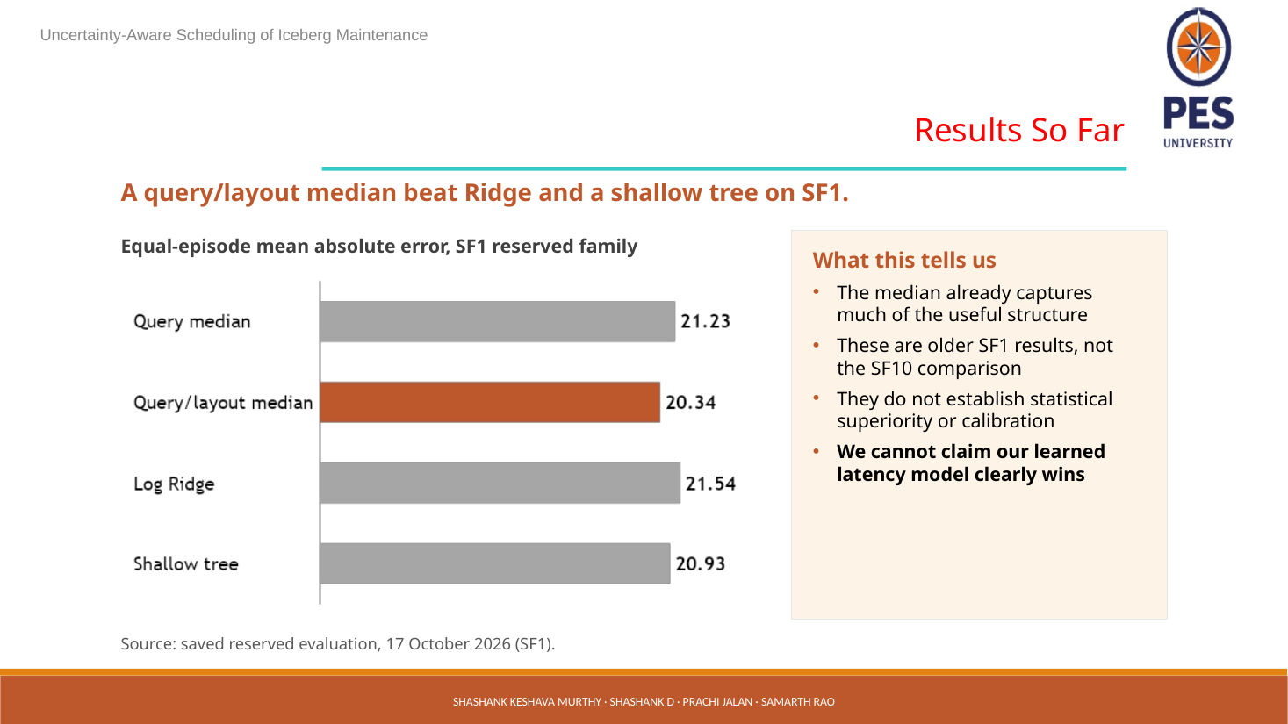
Updated deck screenshot • slide 10 of 15
Purpose: Teach the audience how to read the MAE bars and why the conclusion is modest.
Say it aloud: “These are older SF1 results from one reserved family. The query/layout median has the lowest equal-episode MAE at 20.34 milliseconds. Query median is 21.23; Ridge is 21.54; the shallow tree is 20.93. Lower MAE is better, so the median baseline was slightly better than both learned candidates here. This does not establish statistical superiority, calibration, or an SF10 result.”
What the slide means: MAE is mean absolute error: take each prediction’s distance from the measured service time, ignore whether it was too high or too low, then average. The bars are all close: query/layout median is 0.59 ms below query median, 1.20 ms below Ridge and 0.59 ms below shallow tree. These differences are descriptive, not a significance test. “Equal-episode” gives each held-out episode equal weight after within-episode error calculation, avoiding domination by one large episode. But one reserved source family still cannot support broad generalization.
Technical / evidence note: This is not a “model wins” figure. It is a useful negative/neutral result: simple medians capture much of the available pattern, and model complexity did not show clear benefit in that setup. It is SF1, not the current SF10 comparison. No calibration/uncertainty conclusion follows from MAE.

Slide 11 Why ML shows no edge yet
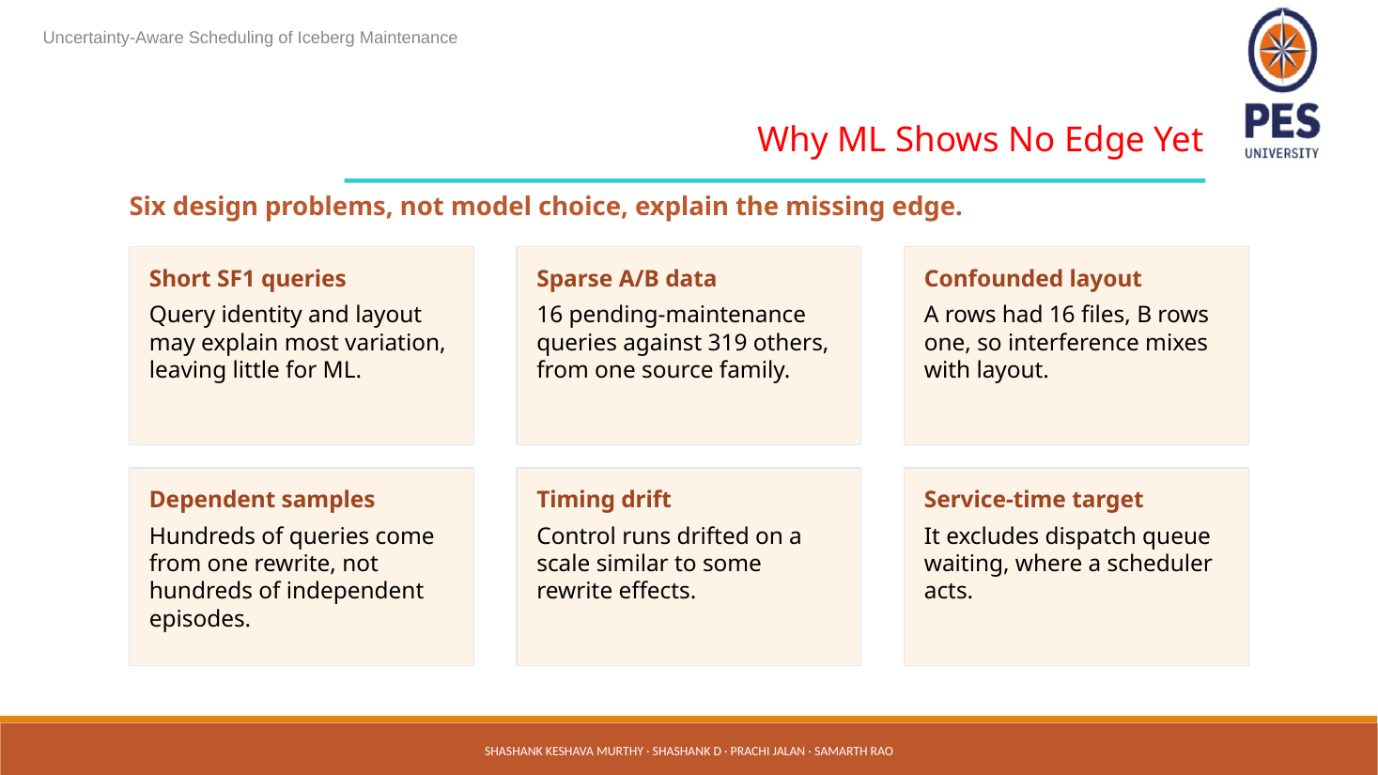
Updated deck screenshot • slide 11 of 15
Purpose: Explain the study-design limits behind the modest SF1 result.
Say it aloud: “The issue is not simply that we chose the wrong algorithm. SF1 queries were short; there were only 16 pending-maintenance rows versus 319 nonpending rows, all from one source family. Pending rows had 16 files while nonpending rows had one, so layout and maintenance condition were mixed together. Many query rows came from one rewrite, and control timing drift was similar to some rewrite effects. Also, service time leaves out the queue waiting that the scheduler must improve.”
What the slide means: Sparse A/B means the two conditions have little balanced support. Layout confounding means any difference could reflect 16 versus 1 files instead of maintenance interference. Dependence means hundreds of rows do not equal hundreds of independent experiments. Timing drift can make before/after comparisons misleading. Finally, the model target and policy target differ: a service-time predictor can be accurate while the policy still makes total response worse because it delays dispatch or starts maintenance at a poor time.
Technical / evidence note: The fix is better evidence design: matched layout and query cohorts, independent blocks/episodes, adequate A/B support, stable telemetry, full offered-arrival accounting, queue wait and whole-cohort response. Do not promise that switching algorithms fixes these structural issues.

Slide 12 Research status and next study
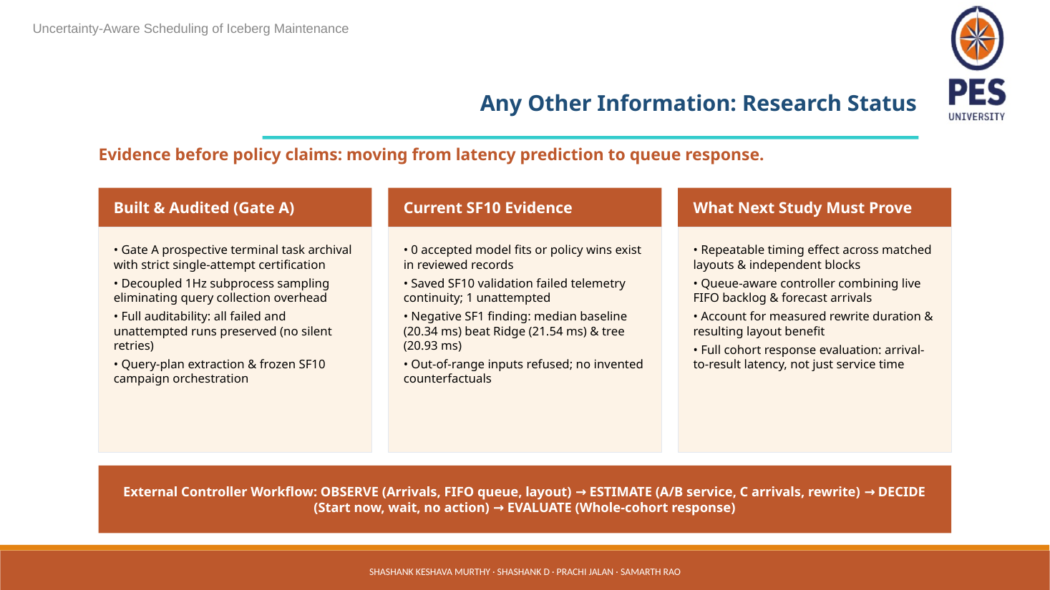
Updated deck screenshot • slide 12 of 15
Purpose: Give the candid status: engineering progress is real, scientific success is not yet established.
Say it aloud: “We have built audit and collection infrastructure, including frozen campaign orchestration, plan extraction, separate 1Hz sampling, and preservation of failed and unattempted attempts. But no accepted model fit or policy win exists in the reviewed records. The saved SF10 validation failed telemetry continuity, and one attempt remains unattempted. Our next study must first show a repeatable timing effect across matched layouts and independent blocks, then account for FIFO waiting, rewrite duration, layout benefit, and every offered query from arrival to result.”
What the slide means: Gate A here refers to an evidence/archival certification gate, not a successful predictive model or paper result. The slide says 0 accepted fits/policy wins; do not relabel exploratory bundles or engineering checks as accepted models. “One unattempted” means its result is unknown; it is not a pass and must remain visible. The failed telemetry continuity means the saved run cannot support the intended model validation; it is not evidence of zero effect. The SF1 result remains the negative baseline result from slide 10.
Technical / evidence note: The workflow OBSERVE → ESTIMATE → DECIDE → EVALUATE is the desired controller cycle. OBSERVE: arrivals, FIFO state, layout, valid host readings. ESTIMATE: A/B service conditions, C future arrivals, plus separately measured rewrite duration/transition. DECIDE: start, defer, or no action under a registered objective and uncertainty rule. EVALUATE: full cohort arrival-to-result, including queue wait, misses, failures and unfinished work. Until those pieces pass independent gates, describe this as a research plan, not a deployed scheduler.

Slide 13 Review 2 divider
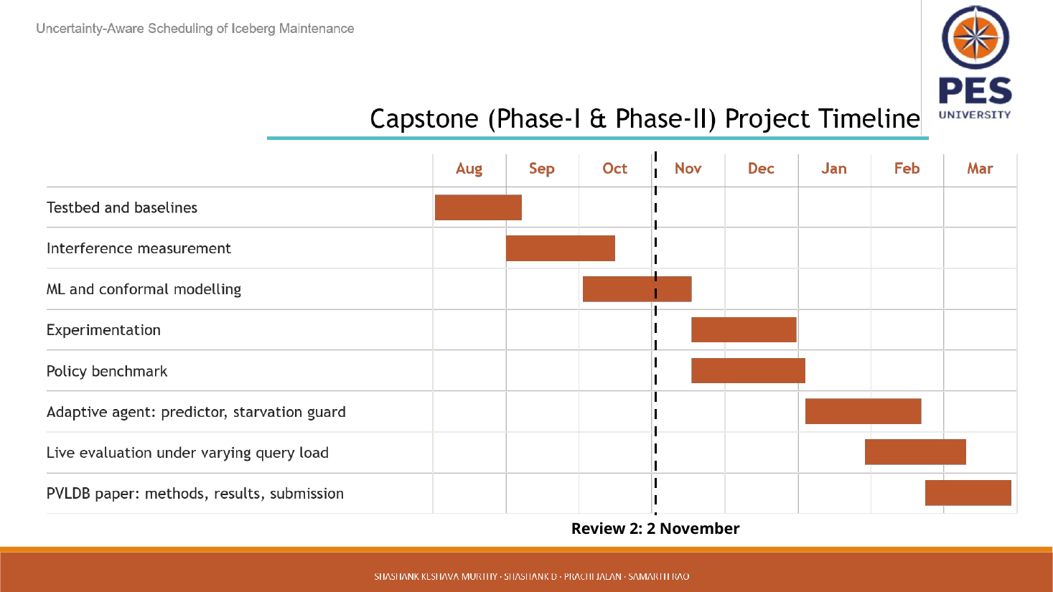
Updated deck screenshot • slide 13 of 15
Purpose: Use as a brief transition.
Say it aloud: “That covers the current problem, system, and evidence. I will now move to the sources and then take questions.”
What the slide means: This slide carries no new measurement or technical claim. It can be skipped verbally if the talk is short, but it gives a pause before references.
Technical / evidence note: Do not treat the date printed here as the date of every result. The evidence slides cite their own dates; the guide is based on the updated deck and repository records available on 3 November 2026.

Slide 14 References
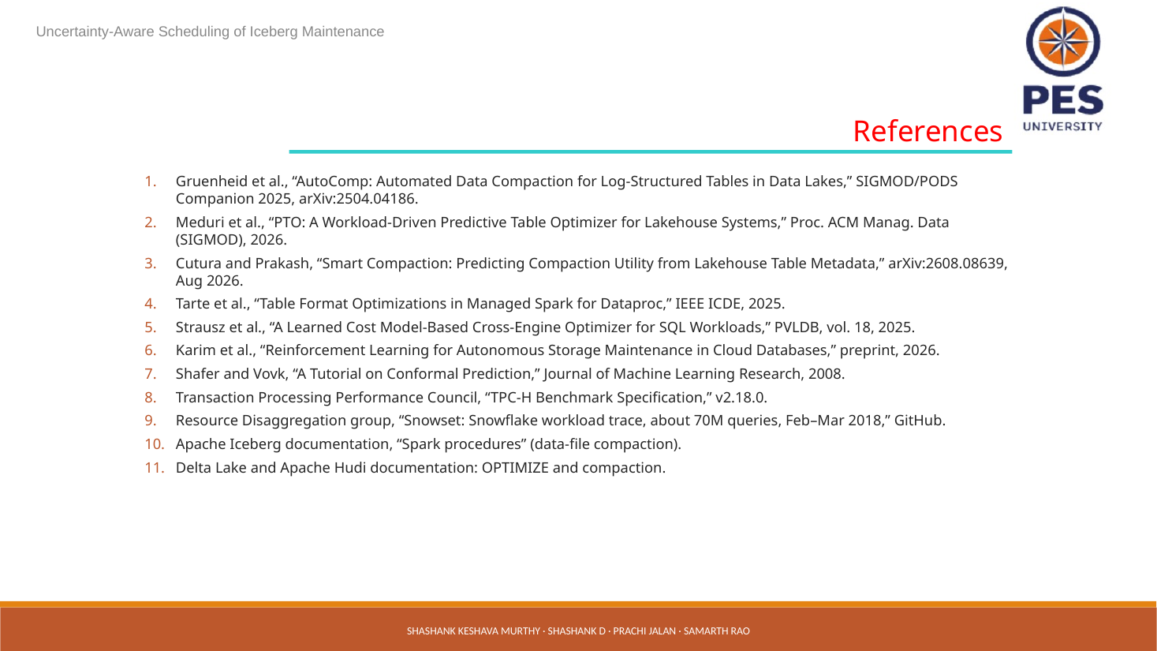
Updated deck screenshot • slide 14 of 15
Purpose: Show that the system connects to lakehouse maintenance, learned models, workload traces and benchmark design.
Say it aloud: “These references cover compaction and table optimization, learned cost estimation, the TPC-H benchmark, Snowset, and Iceberg maintenance procedures. For the final research claim, we will compare the closest work directly on its decision, timing signals, queue model and measured objective.”
What the slide means: The list mixes peer-reviewed papers, a preprint, standards/specifications, dataset documentation and vendor/project docs. Those source types carry different evidential weight. TPC-H defines a benchmark; Snowset describes a trace; Iceberg docs describe procedures; none by itself validates our claimed novelty. The citations should be checked against the actual paper versions and exact claims in the final written survey.
Technical / evidence note: The novelty assertion on slide 6 needs more than a bibliography: a reproducible search strategy and close-work matrix. If an audience member names a paper that also predicts optimization utility or timing, acknowledge overlap and explain the precise distinction rather than defending an absolute “none.”

Slide 15 Thank you
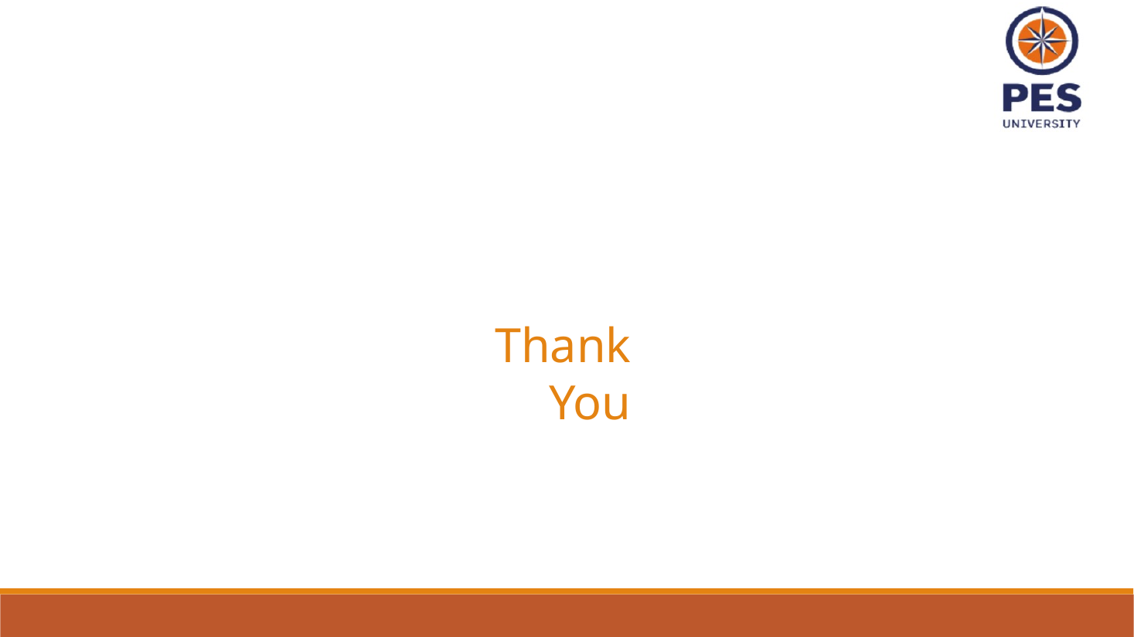
Updated deck screenshot • slide 15 of 15
Purpose: Close with the actual research question and invite critique.
Say it aloud: “The central question is whether a forecast-aware, queue-aware external controller can choose compaction timing that improves whole-cohort response compared with static baselines, under repeatable and honestly measured conditions. We are still building the evidence needed to answer it. Thank you; we welcome questions.”
What the slide means: This closing is stronger than claiming the system already works. It reiterates that the outcome is empirical. A good answer to a question can state what is measured, what is not yet known, and the next gate.
Technical / evidence note: If pressed for the single most important next step: establish a repeatable timing trade-off with identical maintenance actions across matched layouts and independent workload blocks, while preserving the entire offered cohort and queue-wait accounting.

Deep dive: how the queue-aware approach makes a decision
A queue-aware policy must reason about work already waiting as well as work likely to arrive. A simple narrative example: if several queries are already waiting, starting a long rewrite may extend the delay for the whole line. If the queue is empty and the next interval is forecast to be quiet, maintenance may fit with less interference. But those are hypotheses until measured. A controller cannot assume a “quiet window” just because C predicts fewer arrivals: a small number of complex queries may consume more resources than many short queries.
Controller stage | Data it needs | What it would do | Evidence still needed
Observe | Offered arrival timestamps; current FIFO order/depth; current table snapshot/file layout; valid host telemetry; registered query/plan context. | Capture one time-stamped state that could actually have been known at the decision. | Clock alignment, freshness, no missing offered work, exact snapshot/feature provenance.
Estimate | A/B service-time candidates; C arrival-count forecast; measured maintenance duration/resource profile; measured post-rewrite layout state. | Estimate the distribution/range of relevant future workload and action cost. | Adequate independent training, coverage, calibration, held-out family validation, no leakage.
Decide | Queue now, expected arrivals, estimate uncertainty, rewrite cost and expected layout benefit, registered objective/baseline. | Choose start now, defer to a later decision, or skip maintenance. | Pre-registered policy/objective and fair baseline; no post-hoc threshold selection.
Evaluate | All offered requests, arrival/start/end/result state, failures and unfinished work; before/after layout; resource use. | Compare the complete cohort under matched independent conditions. | Repeatable effect, confidence/uncertainty, complete accounting, independent replication.

Important distinction: queue depth is an input snapshot; queue wait is an outcome. C predicts offered arrival counts, not queue depth. The queue’s actual future size depends on arrivals and service completions. Do not describe forecast arrivals as a direct queue forecast unless a separately validated queueing model produces that forecast.

How to explain the SF1 numbers accurately
Method | Equal-episode MAE (ms) | Plain explanation
Query median | 21.23 | For each query identity, predict its typical observed service time.
Query/layout median | 20.34 | Use the typical service time for a query under the observed layout category; smallest error in this comparison.
Log Ridge | 21.54 | A regularized linear model on transformed features; largest MAE among the four shown.
Shallow tree | 20.93 | A small decision tree; better than Ridge here but slightly worse than query/layout median.

Difference from best baseline: query median is 0.89 ms higher than query/layout median; Ridge is 1.20 ms higher; the shallow tree is 0.59 ms higher. These are differences between reported MAEs, not a measured percentage reduction in query runtime. The slide does not show confidence intervals, a significance test, calibration, or SF10 performance. The honest conclusion is “the simple query/layout median was best among these candidates on this older SF1 reserved-family evaluation.”

Common audience questions and confident answers
Why use Snowset if its SQL is unavailable?
It provides observed query-arrival timing, which lets us replay bursty request timing. We map arrivals to six controlled TPC-H-derived SQL templates, so the timing is real-trace-based while SQL/resource behavior is imposed by our benchmark. This is a controlled hybrid, not a faithful replay of the original Snowflake workload.
What exactly does A versus B compare?
A and B refer to observed query service times with versus without our maintenance client having a request pending at feature time. Pending state does not prove that a rewrite was actively consuming Spark resources at that exact instant, and the A/B difference is not automatically causal.
Why not use CPU threshold or cron?
They are fair simple baselines. Cron uses a fixed time; a threshold reacts to current conditions. Our hypothesis is that past-only forecasts and queue state may make better timing decisions. We have not yet shown that they do.
Why does the queue matter if service time is predicted?
A query can wait before service starts. Since the policy changes dispatch conditions, user-visible response must include queue wait plus service. A good service-time estimate alone can still lead to a bad total schedule.
What do the results show today?
The old SF1 comparison shows the query/layout median had the lowest reported MAE among four methods, with modest differences and limited evidence. The current status slide states no accepted model fits or policy wins exist in the reviewed records; the saved SF10 validation failed telemetry continuity.
What does “uncertainty-aware” mean here?
The desired behavior is to know when evidence supports a prediction, report coverage/uncertainty, and refuse out-of-range inputs instead of inventing a value. The slide’s refusal requirement is implemented as a design gate; accepted calibration is not demonstrated by the SF1 bars.
What is the next experiment?
Repeat the same registered maintenance action at different times across matched layouts and independent blocks. Preserve every offered query, queue wait, failures and unfinished work; measure rewrite duration and resulting layout; then evaluate full-cohort arrival-to-result against static and persistence/seasonal baselines.
Can you claim the literature gap is novel?
Not yet from this slide alone. The current claim is that the project is investigating forecast-aware maintenance timing. The final paper needs a systematic review and a direct comparison against closest work before making a “first” claim.
Does a lower MAE mean the scheduler is better?
No. MAE measures prediction error on a particular target. A policy must improve a registered system-level objective such as full-cohort response under matched conditions, without hiding dropped or unfinished requests.
Is 60M rows the size of our running server table?
It is the deck’s approximate SF10 TPC-H LINEITEM row count. It should not be presented as proof of a particular current worker’s physical storage or compressed Parquet/Iceberg bytes unless a saved inventory confirms that exact run.

A two-minute presentation rehearsal
“Iceberg compaction can improve table layout, but it consumes resources while analytics continue. Fixed-time jobs and current-load thresholds do not use predicted future workload. We are testing an external, queue-aware controller around Spark SQL and Iceberg. We use TPC-H SF10 as a controlled schema/data workload and Snowset arrival timestamps to drive the replay; the original Snowset SQL is not available, so we map those arrivals to six TPC-H-derived templates. Candidate A and B estimate query service time under two observed maintenance-client states; C forecasts future arrival counts. The controller must also use the actual FIFO backlog and separately measured rewrite duration and layout benefit. The SF1 exploratory result did not show a learned-model advantage: the query/layout median had MAE 20.34 ms, lower than Ridge at 21.54 and a shallow tree at 20.93, with major confounds and only one reserved family. Current records contain no accepted model fit or policy win, and the saved SF10 validation failed telemetry continuity. So our next scientific gate is to show a repeatable timing trade-off under matched layouts and independent blocks, then evaluate every offered query’s full arrival-to-result time. We are reporting an open research question, not a proven scheduler benefit.”

Source and evidence notes
Primary presentation source: Review 2.pptx in this folder, rendered slide by slide for this guide. Model feature names: three_model_maintenance/protocols/sf10_archive_preflight_20261101.json, comparison.feature_names. Model role and limitations: three_model_maintenance/README.md and docs/project_models_datasets_and_research_rundown_2026-11-01.md. Current readiness and model status: three_model_maintenance/README.md and saved validation referenced on slide 12. SF1 values and caveats: slide 10 source line and docs/project_models_datasets_and_research_rundown_2026-11-01.md. Snowset provenance and replay limitation: docs/project_models_datasets_and_research_rundown_2026-11-01.md, section “Understanding Snowset and our timing replay.”
Evidence boundary: this is a presenter guide, not a new experiment report. No runs were launched to prepare it. It explains what the deck claims and adds cautions based on the repository’s registered model contract and saved evidence. Where the slide is broader than the saved evidence (especially the literature-gap statement and system-level benefit), the guide explicitly marks it as a hypothesis or future test.

